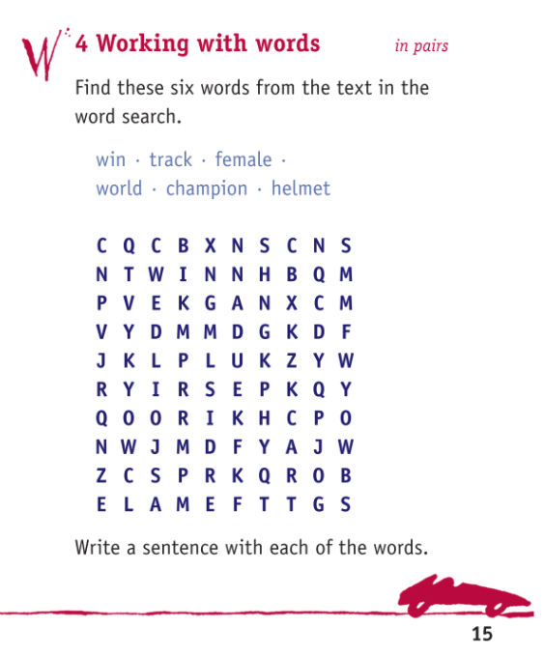

1.______________________________________________________________________________
2. ______________________________________________________________________________
3. ______________________________________________________________________________
4. ______________________________________________________________________________
5. ______________________________________________________________________________

